DEPLOYMENT IN WEBLOGIC USING IBM UDEPLOY

Table of Contents

Check-in the project from SVN repository 2

Configuring the project with Jenkins and scheduling a build with Sonar 3

Deploying in Web Logic using IBMUdeploy 8

Create a component 8

Create Component Process 9

Create a Resource Group 12

Create properties in resource group 13

Create an environment 14

Create Process in Application 15

Run the process 16

Login to WebLogic 17

Navigate to application 18

# Check-in the project from SVN repository

Import the sample Java project into SVN repository.

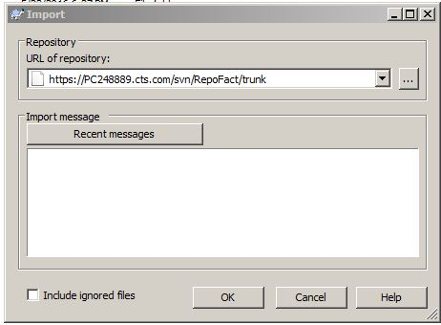

Project successfully imported

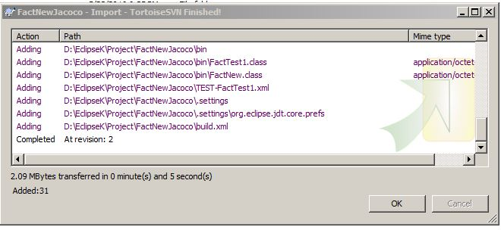

# Configuring the project with Jenkins and scheduling a build with Sonar

1. Go to **Configure** option of the job, go to **Source Code Management**, and select **Subversion.** In Repository URL option, give the URL of Project you want to build.

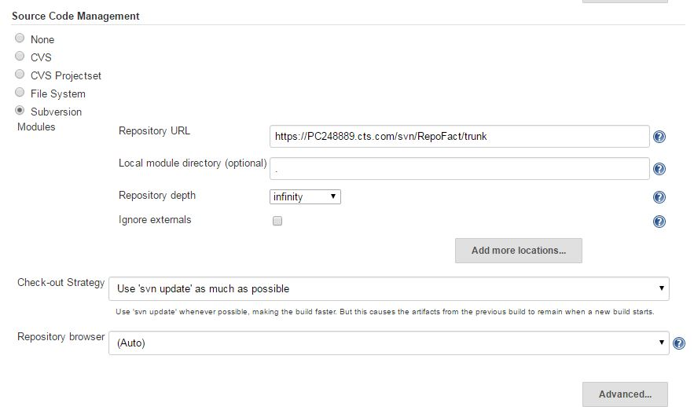

1. To invoke Ant in Jenkins, you need to install plugin, and then **Manage Jenkins** 🡺 **Configure System** 🡺 **Ant Installation.** Specify following details-:

Name-: specify name of ant

Ant_Home-: give name of home directory of ant

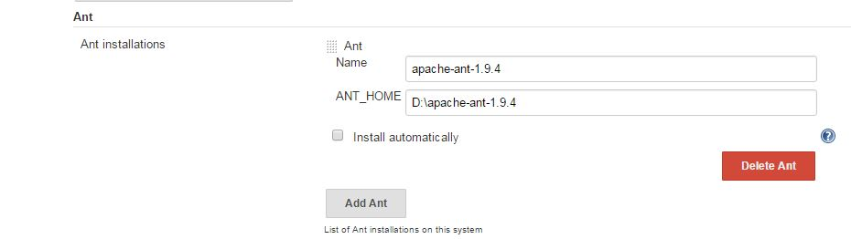

Using **Configure** option of your job, Scroll down to bottom of page to **Add build Step** and select **Invoke Ant**.

Specify Ant version from dropdown and Name your Target.

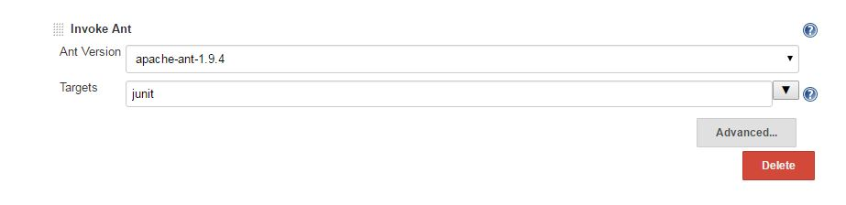

1. In **Execute SonarQube Scanner**, in Analysis properties give the property of sonar (or you can include the sonar-project. properties file in the root folder of project)

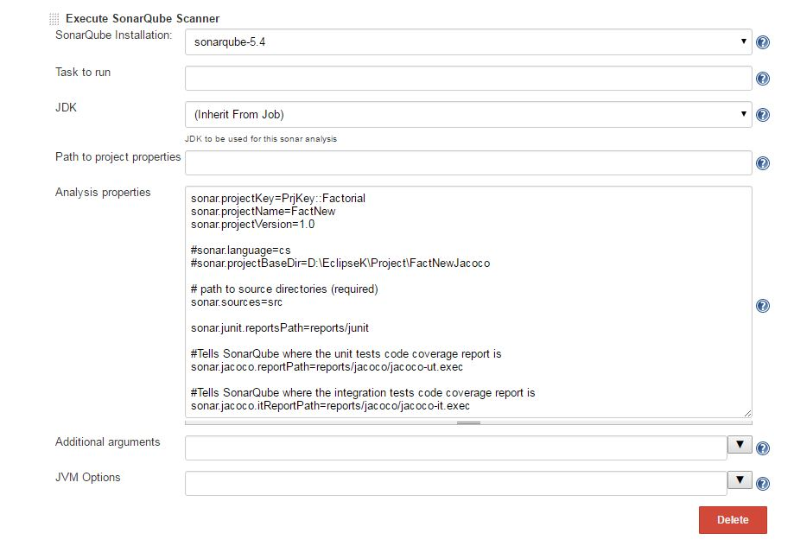

1. Schedule a build for your job in Jenkins from **Build Now** option. In the console output you will find analysis successful.

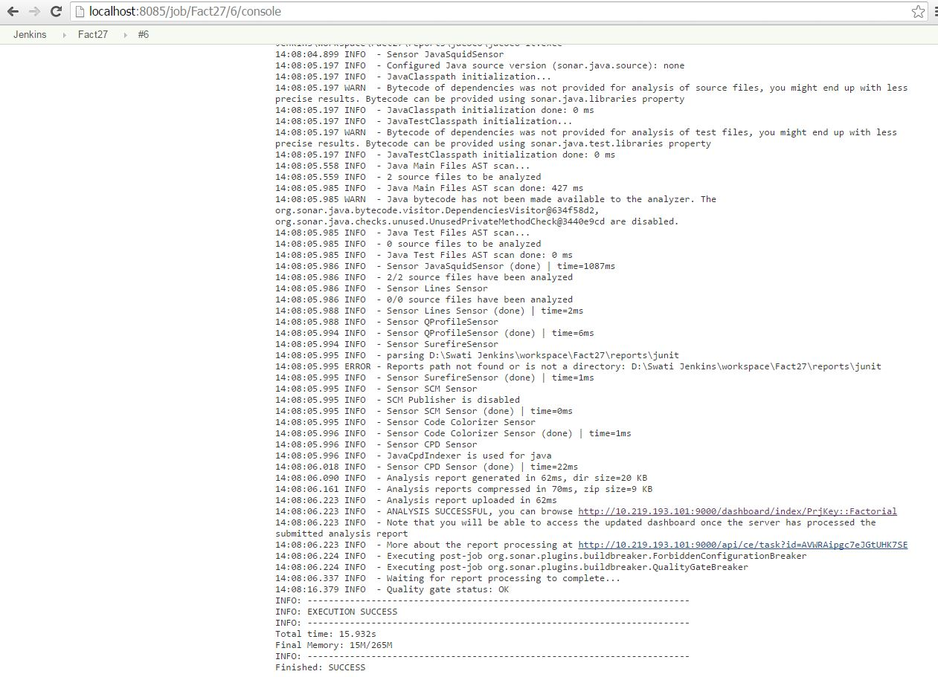

Browse the URL of sonar, Quality Gate Passed in SonarQube.

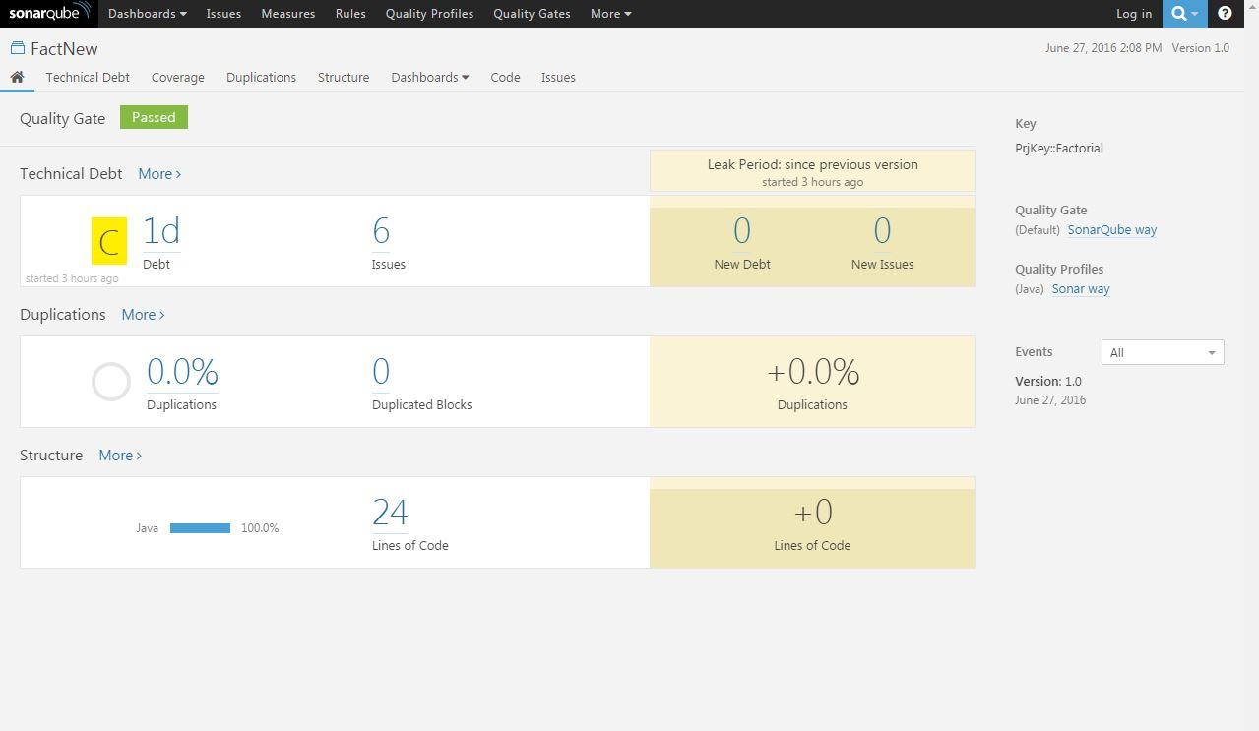

# Deploying in Web Logic using IBMUdeploy

## Create a component

Create a component to add the war file and set the Source Configuration Type to File System (Versioned) and Import Versions Automatically checked.

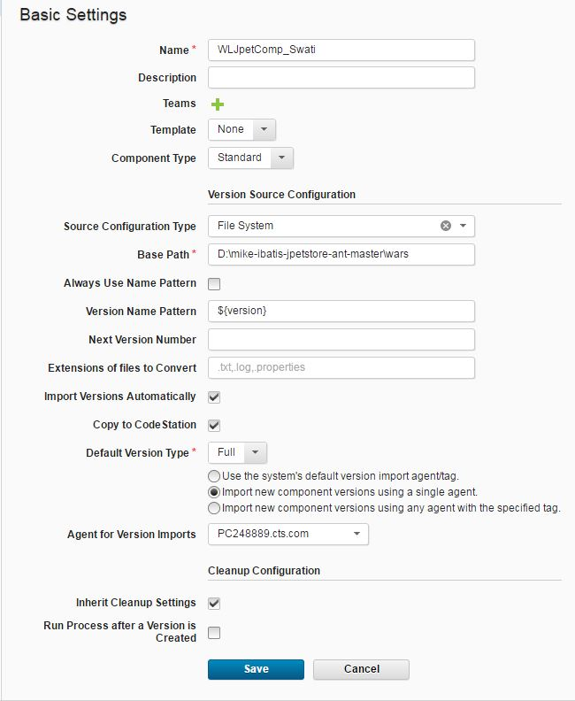

## Create Component Process

Click Component 🡺 Select your component 🡺 Processes 🡺 Create Processes

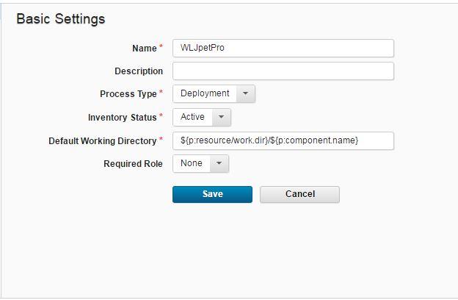

Process WLJpetPro is created.

Click the process you created (WLJpetPro). The process opens in the process editor. This editor shows the steps in the process in a graphical form, as a flowchart. The **Start** and **Finish** boxes represent the beginning and the end of the process. We need two steps “Download Artifacts” step (default) and “Deploy” (WebLogic).

For Download Artifacts step enter the default values only.

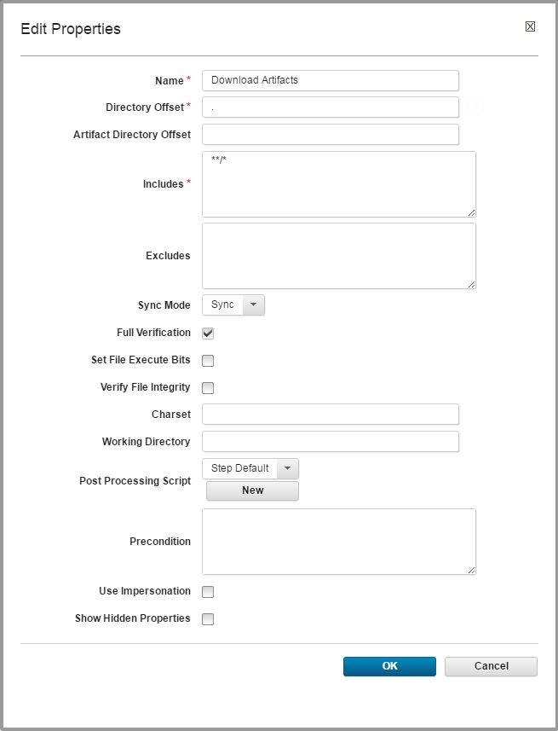

For deploy step enter the following:

* Deployment Name : **sample**
* Admin URL : t3://<hostnameofweblogicserver:port>
* User Name : User ( or username you set while installing WebLogic )
* Password: password for your WebLogic server
* Target: Name of your Target server
* Source : **sample.war**
* Deployment Classpath: leave it as is, we shall create property in Resource later.

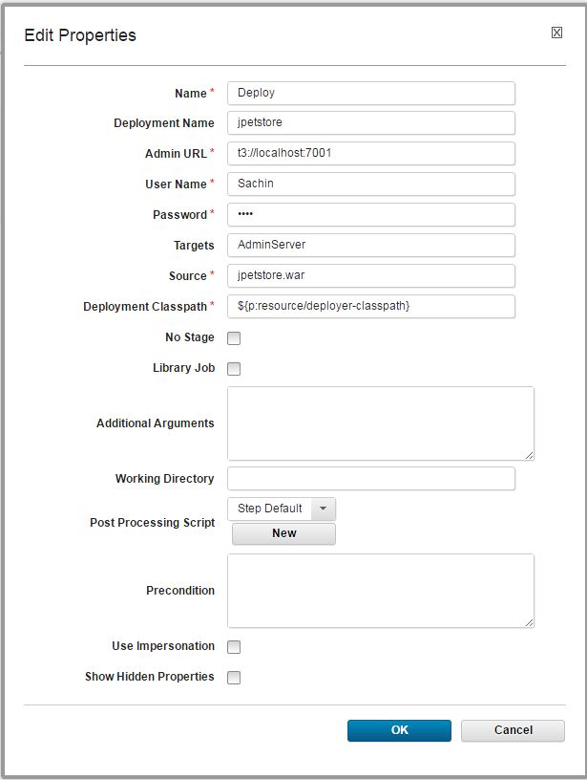

Now the process has four steps, as in the following figure:

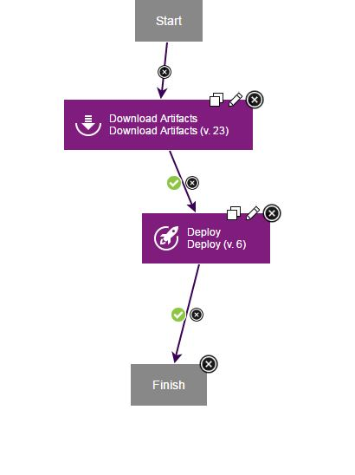

## Create a Resource Group

Click Resources 🡺 Create Top-Level Group

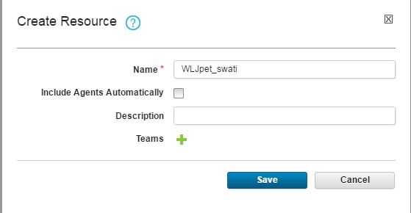

Add agent along with Component as shown below.

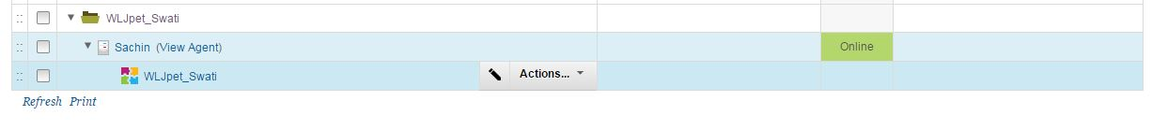

## Create properties in resource group

In Resource Groupcreate property **deployer-classpath** and add path to weblogic.jar (%Oracle_Home%\wlserver\server\lib\weblogic.jar) as shown in screenshot below.

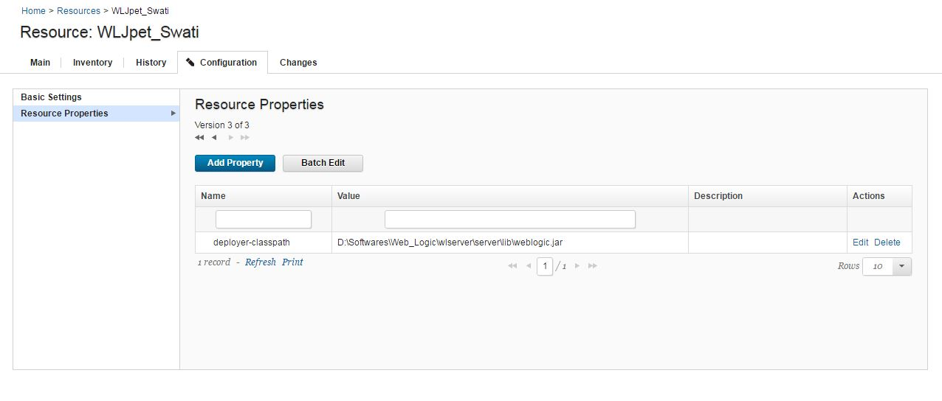

## Create an environment

In Application, create environment **DEV** in and add resource group to it.

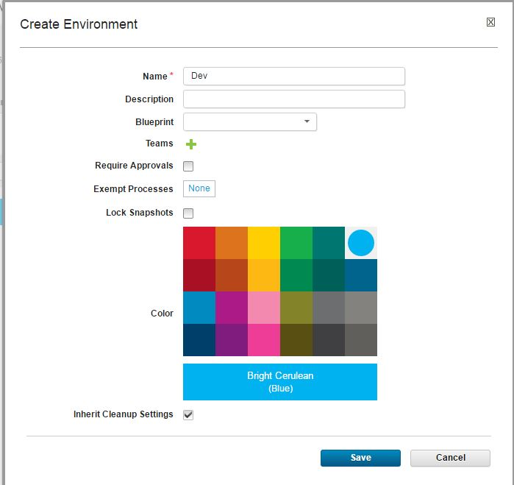

Click on your environment (Dev) 🡺 Go to Add Base Resource 🡺 select your Agent and component

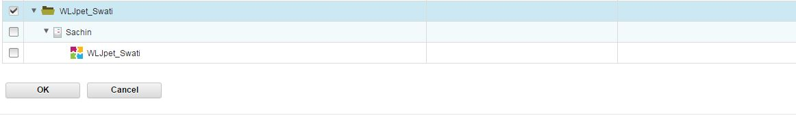

## Create Process in Application

Create Process in Application 🡺 Edit

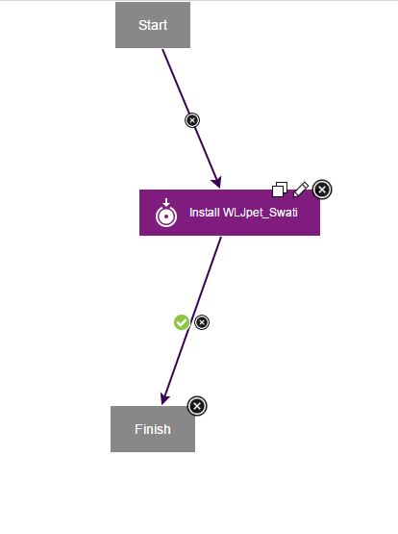

## Run the process

We are now ready to deploy. While deploying select Version of your Component to deploy. Deployment will be successful as shown below.

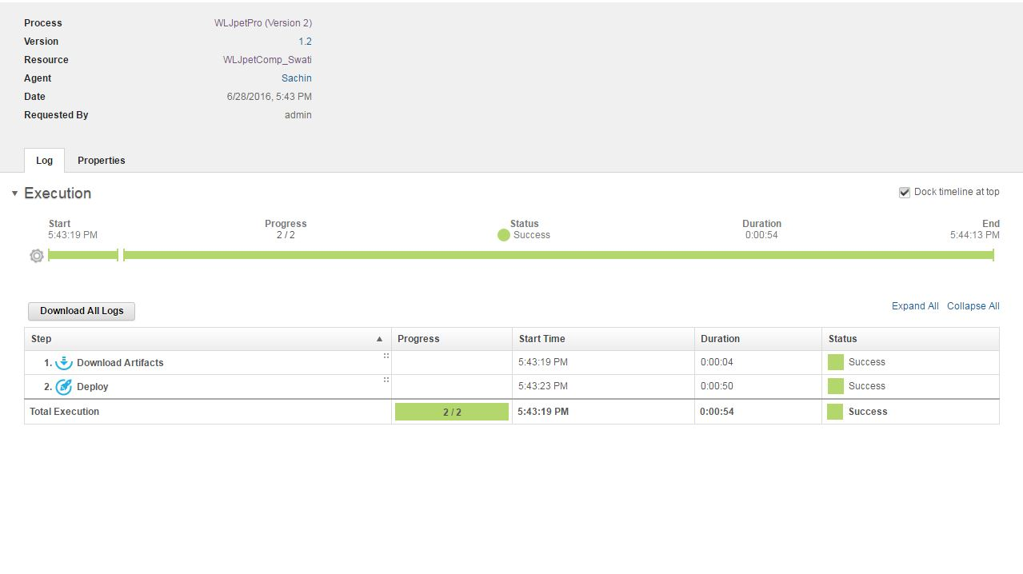

## Login to WebLogic

Login to <http://localhost:7001/console> and check same by navigating to  
base-domain->Deployments.

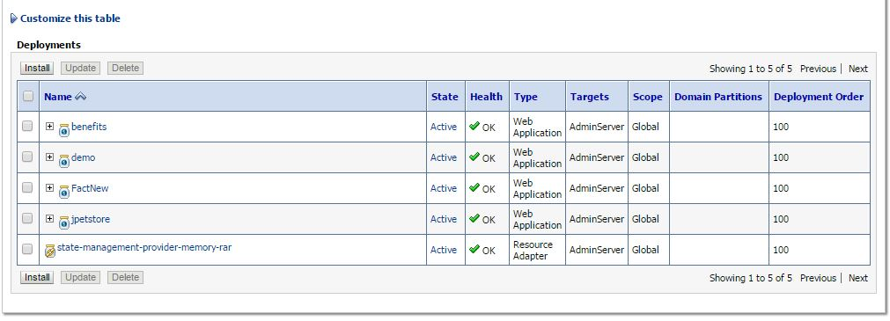

## Navigate to application

